📘 Industry Case Study:

Engineering Plastic Modification Waste Recycling & Crushing System
Shanghai YUEDU Technology Co., Ltd. — YUEDU Shredders
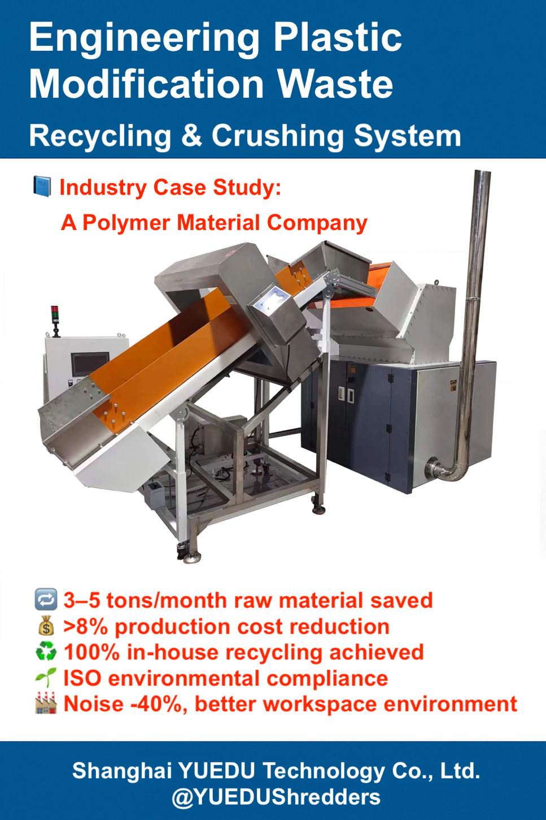

I. Client Background
A Polymer Material Company
A high-tech enterprise specializing in the research, production, and sales of engineering plastics, special engineering plastics, and customized modified plastics.
Main products include PA6, PA66, PC, ASA, PBT, PET, PPS, and PPA modified resins, widely used in automotive, electronics, industrial equipment, and medical devices.
The company’s production line features state-of-the-art extrusion, feeding, and testing systems, maintaining strict standards for material stability, pellet consistency, and sustainable recycling.

II. Pain Points in the Industry
During the production of modified plastics, manufacturers commonly face the following challenges:
- Large quantities of head, tail, trial, and defective materials generated during extrusion and granulation.
- R&D samples and unqualified quality-control materials cannot be directly reused.
- Glass-fiber-filled or high-temperature PPS materials are difficult to crush and cause excessive wear.
- Residual materials after color or formula changes are hard to recycle.
If these wastes cannot be efficiently crushed and reused, they will:
- Increase raw-material waste and procurement costs
- Occupy valuable workshop space and add management burden
- Reduce the efficiency of ISO quality system operations
- Hinder green production and sustainability goals

III. YUEDU Shredders’ Solution Overview
To address these specific challenges in the modified-plastic industry,
Shanghai YUEDU Technology Co., Ltd. (YUEDU Shredders) developed a
🔹 Closed-Loop Edge Trim Crushing & Recycling System tailored for engineering-plastic factories.
System Name: YD-SL Series Silent Plastic Shredding System
System Composition:
- Main Models: YD-SL600 / YD-SL3040
- Crushing Type: Rotary blade + fixed knife combination, 3 mm – 8 mm particle size optional
- Applicable Materials: PA6, PA66, PC, PBT, PPS, PPA, ABS, PC/ABS alloys, etc.
- System Configuration:
  - Automatic conveyor feeding system
  - Magnetic separation unit for removing foreign metals
  - Dust-proof sealed cover + static-elimination unit
  - High-chromium wear-resistant blades (for glass-fiber-filled materials)
  - Dual cooling system (water + air)
  - Powder collection barrel + filtration and dust-removal unit
Workflow:
Edge trim / waste → Conveyor feeding → High-speed shredding → Screening & classification → Pellet collection
Crushed particles can be directly fed into a granulator or mixer for reprocessing.

IV. Technical Advantages
Advantage | Description
⚙️ Multi-Material Compatibility | Supports PA, PC, PBT, PPS, and various engineering plastics
💎 Wear-Resistant Blades | Made of high-chromium alloy steel, ideal for glass-fiber/mineral-filled materials
❄️ Cooling System | Temperature rise < 25 °C ensures stable polymer properties
🔇 Low-Noise Design | Operation noise below 68 dB, suitable for workshops or labs
♻️ Environmental Recycling | Enables closed-loop reuse of edge trim, compliant with ISO
🧹 Easy Cleaning | Modular structure allows quick formula change and easy maintenance

V. Results & Benefits
After implementation, the client achieved:
- 🔁 Reduced raw-material waste by 3–5 tons per month
- 💰 Decreased production cost by over 8 %
- ♻️ Achieved 100 % in-house recycling of edge trim
- 🌱 Fully compliant with ISO environmental standards
- 🏭 Lowered noise level by 40 %, improving the working environment

VI. Client Feedback
“After adopting the YUEDU shredding system,
our modified-plastic scraps are efficiently recycled with consistent particle size and no dust emission.
The machine runs quietly and reliably, greatly supporting green production and cost optimization.”
— Technical Director, Polymer Material Company

VII. Conclusion
The YUEDU Shredder System helps the engineering-plastic modification industry
transform from “waste accumulation” to “material circulation.”
It provides a solid foundation for energy saving, cost reduction, environmental protection,
and intelligent manufacturing upgrades.

Specific Application Scenarios and Customer Value
Application Stage / Scenario | What Shanghai YUEDU Technology Co., Ltd. Can Do | Value / Benefit
Production Scrap / Defective Materials / Head & Tail Waste Recycling | Shred or crush large waste materials, edge trims, and non-conforming products into reusable granules or powder. | Reduce material waste, lower raw material consumption cost, enable in-plant recycling.
Reinforcement Filler / Fiber / Additive Pretreatment | For fillers such as glass fiber, mineral powder, or short fibers, the shredder can pre-process them into uniform particle sizes. | Ensure consistent particle size, improve dispersion, enhance the performance of modified plastics.
Waste Plastic / Recycled Material Pretreatment & Regeneration | For waste plastics, defective parts, mold residues, or obsolete samples, the shredder can crush them into reusable or recycled materials. | Reduce new raw material purchases, improve environmental sustainability, lower waste disposal costs.
Additive / Functional Agent Grinding Before Mixing | Some additives or modifiers in the formula may need fine grinding before mixing to achieve even dispersion. | Improve dispersion, minimize agglomeration, ensure uniform product performance.
R&D / Sampling / Formula Development Stage | During small-batch R&D or testing, materials can be mixed, crushed, and tested at various ratios efficiently. | Increase testing efficiency and flexibility in formulation trials.
Granule / Powder Pre-Crushing Before Pelletizing | Pre-crush materials into uniform particle sizes before pelletizing to ensure stable feeding and improve efficiency. | Enhance pelletizing line performance, reduce clogging, increase process stability.
Fine Powder / Micro-Pulverization | For advanced materials requiring ultra-fine powder (used in fillers, additives, or composite materials), the shredder provides high-precision and high-purity pulverization. | Improve uniformity and mechanical properties in high-performance applications (e.g., reinforced sheets, composite structures).

🔗 Recommended Equipment Models
Series | Model | Application Description
SL Silent Series | YD-SL600 / YD-SL700 | For glass-fiber-reinforced and high-hardness materials
QL Heavy-Duty Series | YD-FSJQL400 / 500 / 600 | For continuous shredding of PA / PC modified resins
SL Belt-Feed Series | YD-SL3040 / 6090 | For mass continuous operation or integration with extrusion lines
Custom System | YD-SL60120 Intelligent Shredding System | Fully automated closed-loop recycling with extruder & pelletizer integration

📞 Contact Us
Shanghai YUEDU Technology Co., Ltd. (YUEDU Shredders)
🌐 Website(Global): www.yuedushredders.com（VPN only in China, server in Google）
🌐 Website(China): www.91suizhiji.com (server in China)
📧 Email: yuedushredders@gmail.com / denghao8410@gmail.com
📱 Tel: +86-15901782779
🏭 Application Fields: Engineering Plastics | Modified Resins | E-Waste | Recycling

🌍 Keywords
#EngineeringPlasticShredder #ModifiedPlasticRecycling #PA66ShreddingSystem #PCShredder #GlassFiberRecycling #PPSCrushing #IndustrialShredder #PreGranulationProcessing #YUEDUShredders #ShanghaiYUEDUTechnology

